FYP-I Fortnightly Sign-Up Sheet Fall 22
Course: CS Project-1 Project Code: P-2067 Project Name: CapstoneConnect
Group Members Names & Reg#: Ayushmann Kukreja (CS201245) Murtaza Mehdi (CS201211) Abdul Rehman Khan (CS201250)
Supervisor Name: Ms. Urooj Waheed Co-Supervisor’s Name: Ms. Yusra Mansoor
Meeting # | Date | Agenda (Brief Statement) | Attended By | Supervisor’s Sign | Co-supervisor’s Sign | PMO’s Sign
1 | 27/10/2024 | Discussion About FYP Idea:  Many innovate ideas were discussed with both supervisor | Ayushmann  Mehdi  Abdul Rehman | 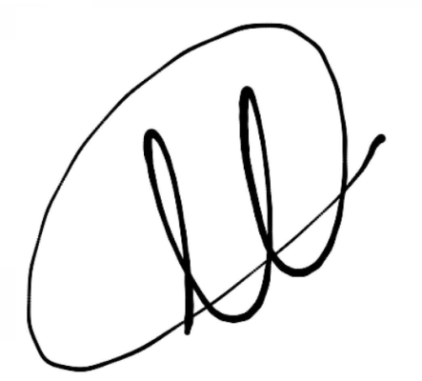 | 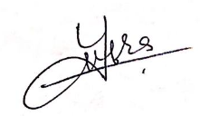
2 | 30/10/2024 | Finalized FYP topic and discussion about further challenges | Ayushmann  Mehdi  Abdul Rehman |  | 
3 | 20/11/2024 | Discussion about Project Proposal | Ayushmann  Mehdi  Abdul Rehman |  | 
4 | 28/11/2024 | Discussion regarding Project Defence | Ayushmann  Mehdi  Abdul Rehman |  | 
5 | 5/12/2024 | Discussion regarding conducting a survey among students and supervisors | Ayushmann  Mehdi  Abdul Rehman |  | 
6 | 13/12/2024 | Discussion about what necessary information is to be stored about student and supervisor | Ayushmann  Mehdi  Abdul Rehman |  | 
7 | 19/12/2024 | Discussion about results of survey | Ayushmann  Mehdi  Abdul Rehman |  | 
8 | 3/1/2024 | Discussion regarding making innovative user interface | Ayushmann  Mehdi  Abdul Rehman |  | 
9 | 15/1/2024 | Discussion regarding SDS and SRS | Ayushmann  Mehdi  Abdul Rehman |  | 
10 | 21/2/2024 | Further discussion about SDS (Software Architecture, Sequence Diagram) | Ayushmann  Mehdi  Abdul Rehman |  | 

